**Project Development –Delivery plan sprint-4**

IoT Based Safety Gadget for Child Safety Monitoring & Notification

**TEAM ID:**PNT2022TMID16946

**Creating Cloudant DB and integrating Node-Red with the Web UI**

# Create Cloudant DB:

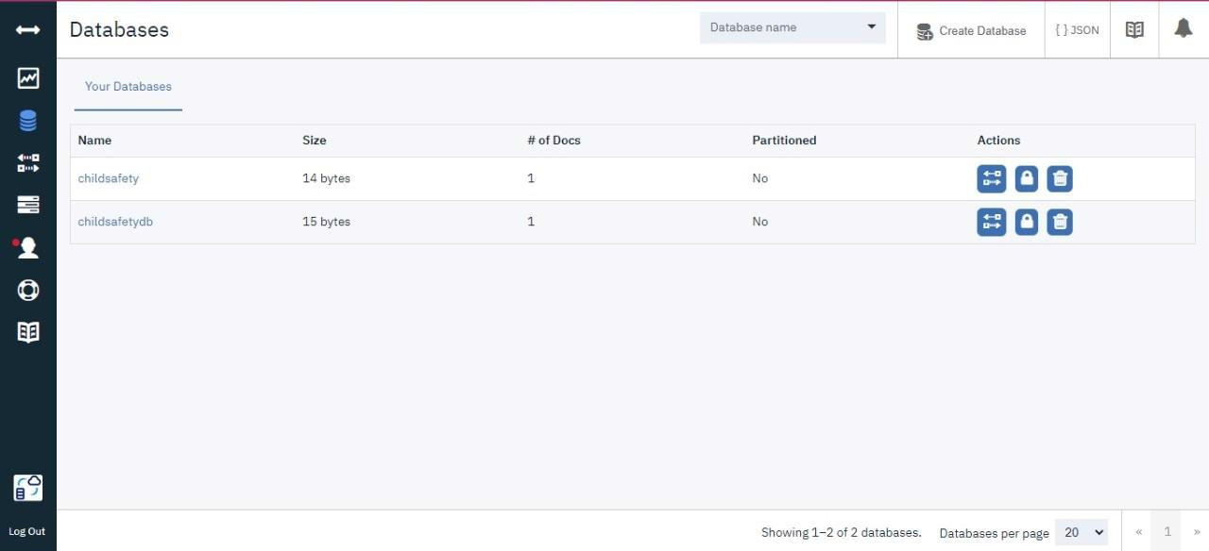

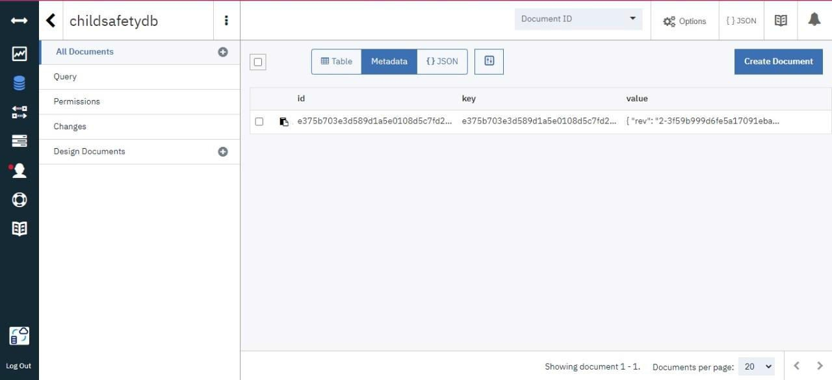

**Node-Red Service with Cloudant Database:**

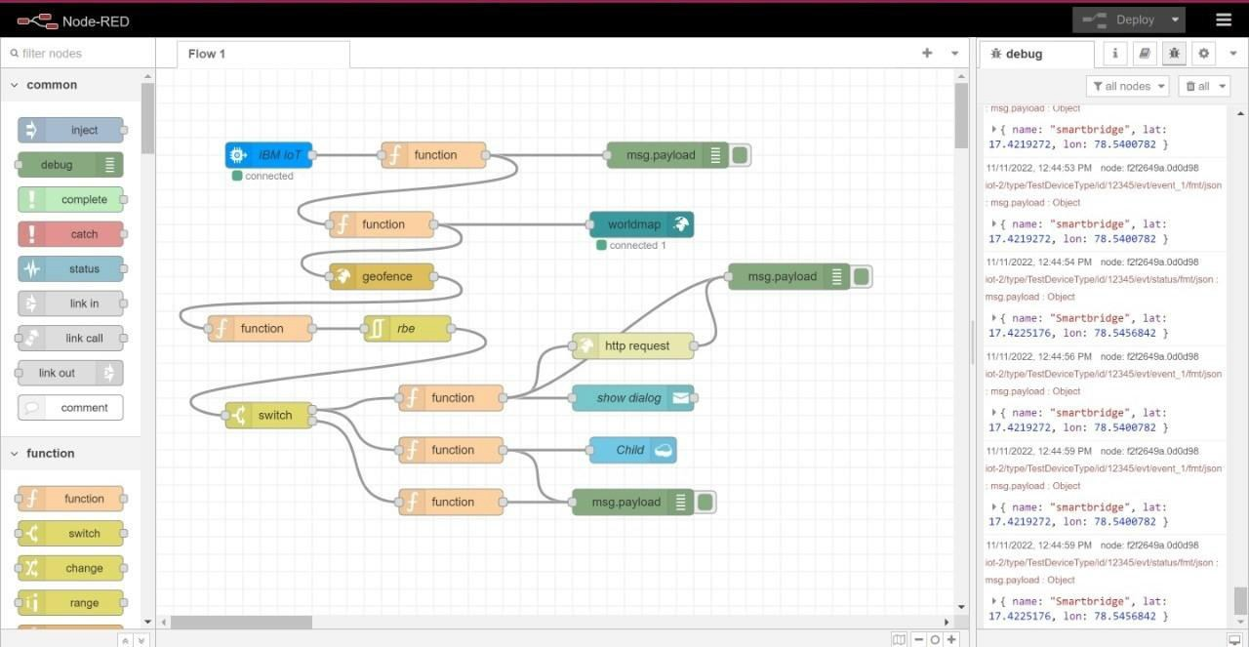

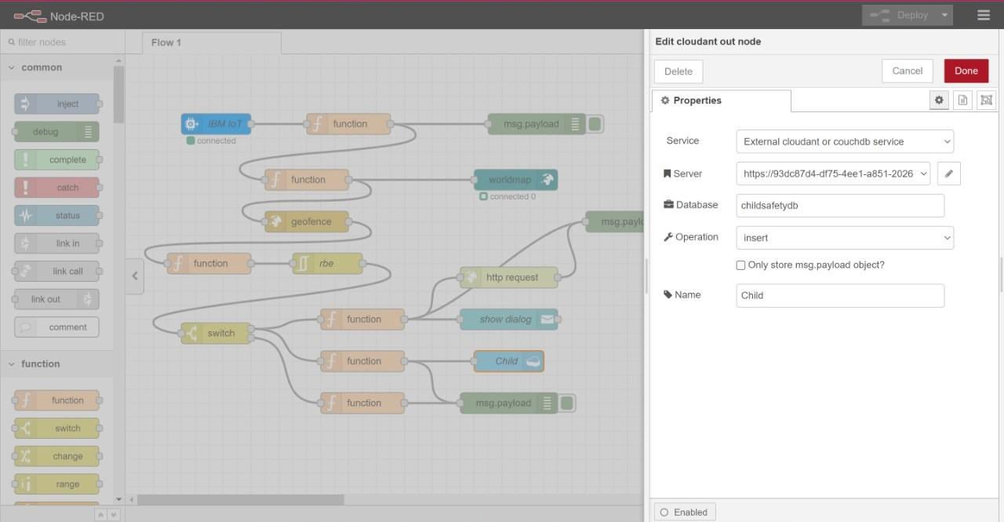

**Node-Red Dashboard(Web ui):**

